Assignment1

- Create Registration form with fields as
UserName | TextBox
Password | TextBox
Email | TextBox
Mobile | TextBox

Save the values into database using
  - Request [ A method to save the values into database using request]
  - Parameters[ A method to save the values into database using parameters]
  - FormCollections[ A method to save the values into database using form collections]

Apply the validations using JavaScript.

Assignment2

- Create a Model for the fields(UserDetails)

UserName | TextBox
Password | TextBox
Email | TextBox
Mobile | TextBox

Create a Controller & View using Model to
- Add a User (Design the action and view accordingly)
- View Users (Design the action and view accordingly)
- Delete a User (Design the action and view accordingly)
- Edit a User (Design the action and view accordingly)

Assignment3

Add Validations to the Model using Data Annotations

Assignment4
Create a View Similar to shown below which can add a new user and show the users in a Single View
The View should be as shown below. On click of Register it should add a new user to the database.

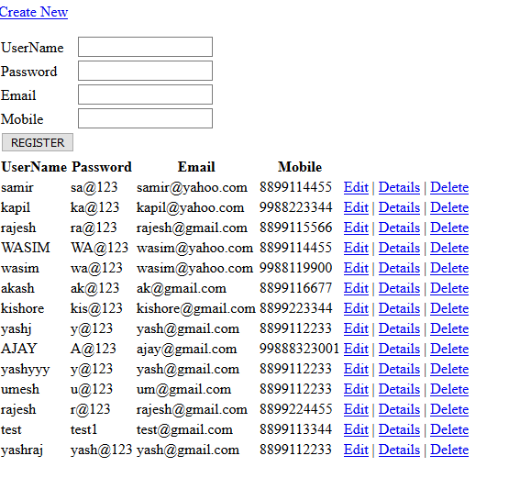

Assignment5

Modify the Assignment4 to add a checkbox to delete multiple users
A Check Box for Delete should be added to each row.
User will select multiple checkbox and check on delete button.
It should delete multiple users.
Also add pagninations to the show users page.

Assignment6
Create a Student Registration form similar to this

