Lab Practice Guide – 6

HTML
Case Study 1
Design a HTML page to display the following table in the page.

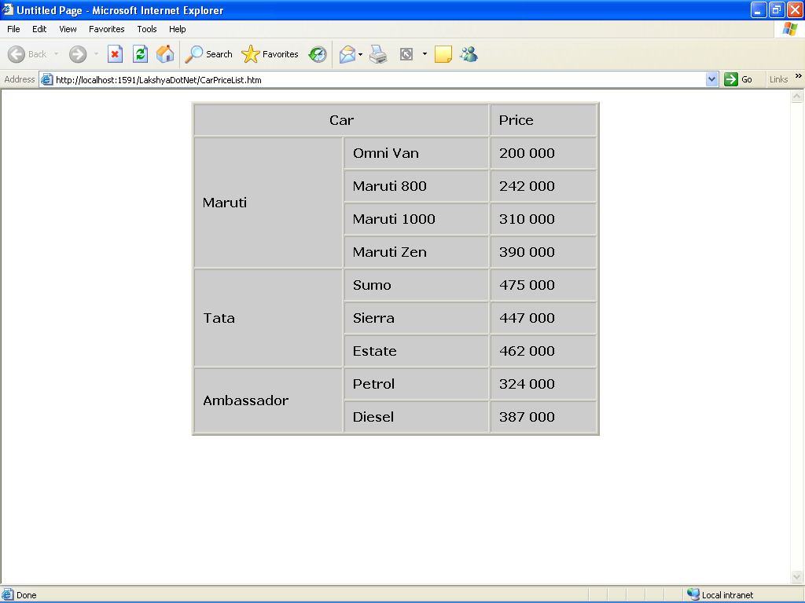

Case Study 2
Design a sample Form in html for the Training Annual Convention as follow.
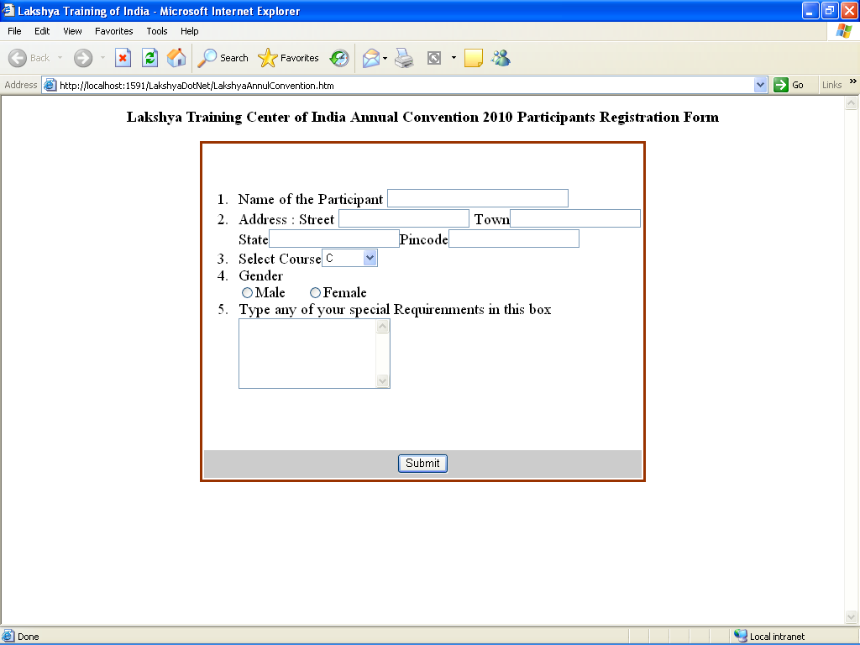

Case Study 3

Create a frameset page in html as follows. Display different pages or images in each frame.

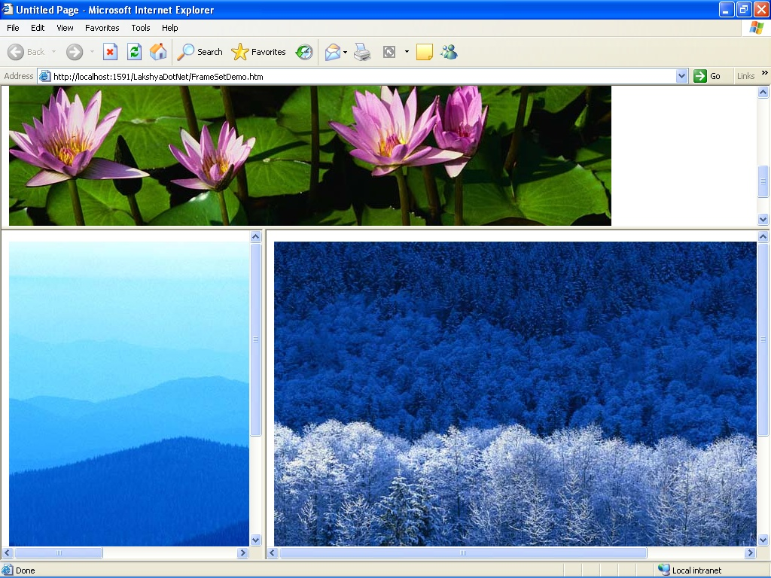

Java Script

Case Study 4
Write a program in java script to find the factorial of a number.

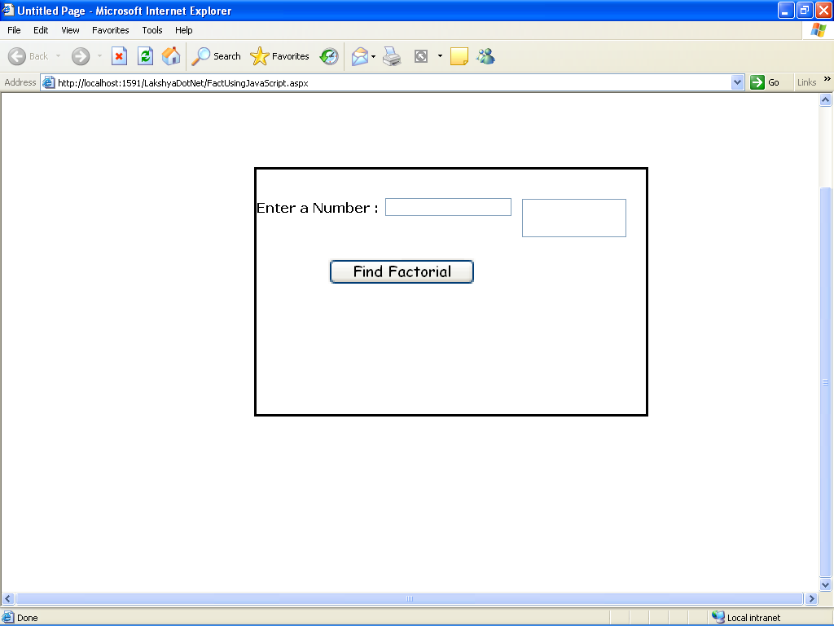

Case Study 5

Write a program in java script to accept only alphabets in textbox.

Case Study 6
Create a web form, place a Textbox control into it. When a user Enter data in the Textbox. It accepts only alphabets (a-z) .After insert data inside the text box it checked the first character of the string should be Uppercase. (Using JavaScript)

Case Study 7

Take a radio button list on the page containing color name as red, blue, black, green, etc. If user selects any option the background color of the page make be changed.

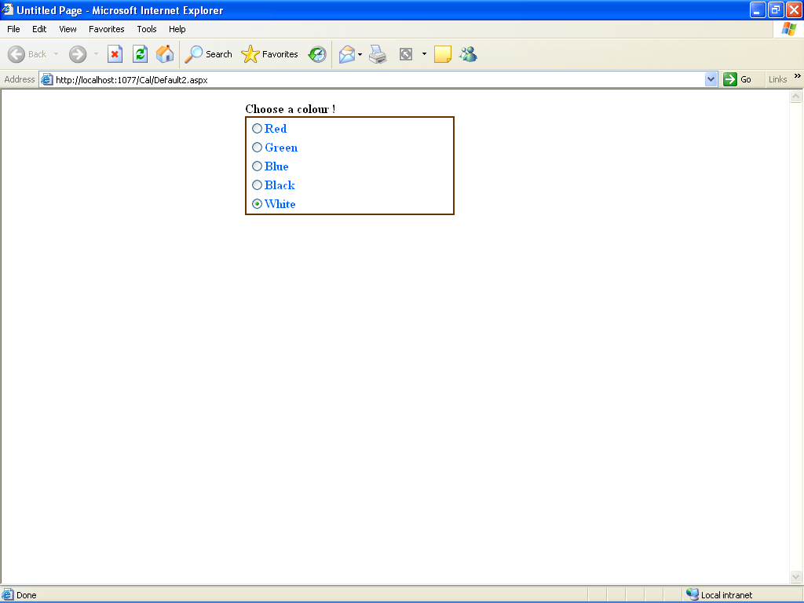

Case Study 8

Create a web form, place a gridview control into it. Display records from a database table in it. Also allow it to perform following operation:
- Select an entire Record
- Edit the Selected Record
- Delete the selected Record
- Insert a new Record

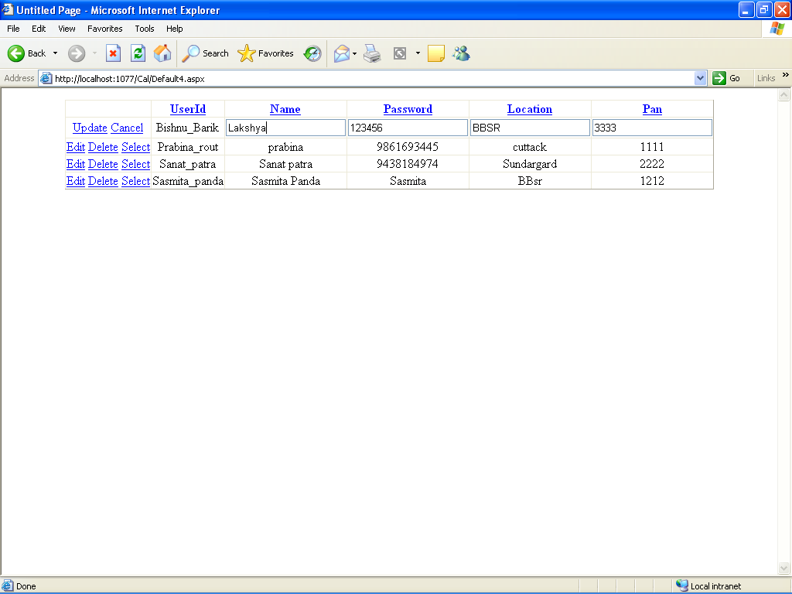

Case Study 11

Create a web application showing the use of validation controls i.e. required field validator, range validator, regular expression validator etc.

Case Study 12

Create a web page for Login using Login control. If the userid and password is valid than it redirect to another page where userid will be displayed in a label as Hello <userid>

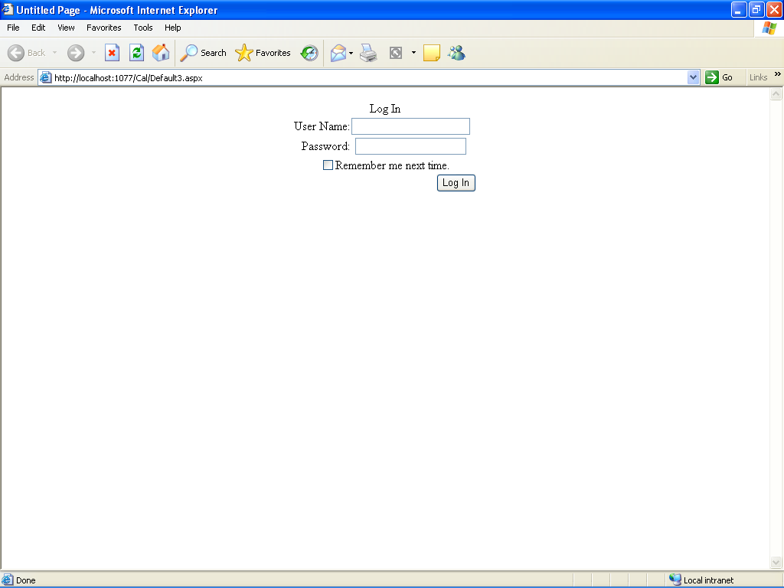

Case Study 13

Create a web application that uses Navigation controls (i.e. sitemap, tree view & menu navigator) for easy navigation among various pages of the web application.

