Everything you need to know about becoming
A web developer

Becoming a web Developer you should know the Following things:-
Web designing is growing as the most popular and in demand field in the technology oriented software stream. Enosis Learning Teaches the all how to create a Web site based on customer need which will reflect what do you want to convey to the customers in the easiest and convenient way. Web designers will typically be expected to have a degree-level education combined with relevant work experience and vocational skills. You might also be required to have specialized degrees in varying fields such as graphic design, information design and interface design.
We exert following technologies for our Web Development:
- Adobe Photoshop
- Adobe Illustrator
- Adobe Dreamweaver
- Html (Hypertext Markup Language)
- CSS (Cascading Style Sheets).
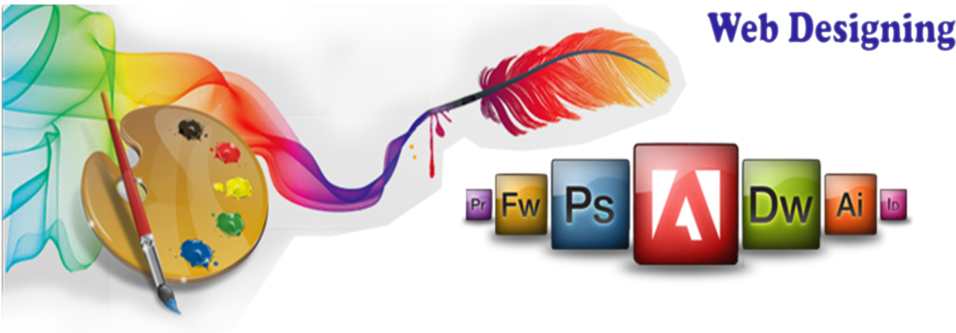
Why To Choose the enosis Learning:

- We provide students with requisite knowledge and skills to enable them to pursue a career in the IT Industry.
- We provide skill based professional training for career advancement
- We provide the entry level and mid career professionals with concrete building blocks to create a path for full employment and successful care

Enosis Learning is one of the best institute in Pune for web designing classes. In this course all the topics related to web designing are covered. Enosis Learning is pioneer in training Institutes providing various professional training courses for various technologies. Institute is constituted by proficient professionals and experts. They provide cost effective training to individual and organization, consulting services to individuals in various fields like Web Designing & Development, C,C++,Dot Net, Java Language and much more.

If You want know more about the Web development course you just visit on www.enosislearning.com or just call on-7757012051/52/55.

